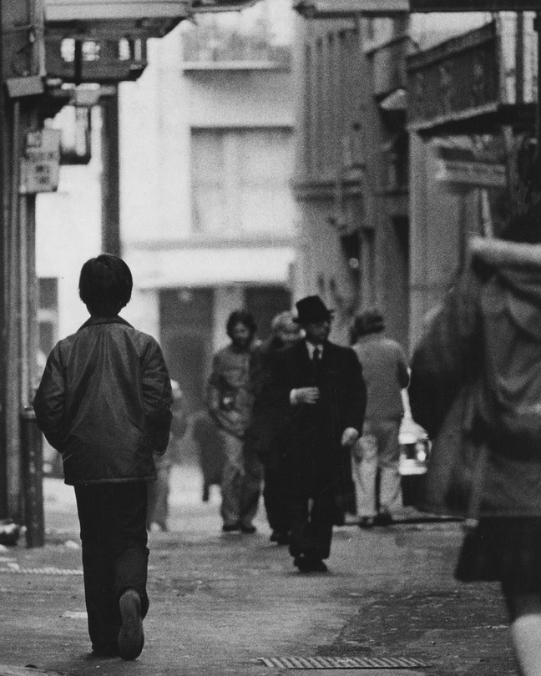

Boy walking home on Ross Street in the historic district of Chinatown in San Francisco in 1966 (Vincent Maggiora / San Francisco Chronicle / Getty)

SEPTEMBER 26, 2023, 8 AM ET

SHARE & GIFT

[SAVED STORIES](https://accounts.theatlantic.com/accounts/saved-stories/)SAVE

[BOOKS](https://www.theatlantic.com/books/)

THE PAINFUL AFTERLIFE OF A CRUEL POLICY

Across memoir and fiction, Fae Myenne Ng has explored the true cost of the Chinese Exclusion era.

By [Mae Ngai](https://www.theatlantic.com/author/mae-ngai/)

In an age of democratized self-expression, you need not be Serena Williams or Prince Harry to write a memoir—or for people to want to read about your life. Not all of these first-person works are good, but more of them means that some will be good, even fascinating. Take an ever-swelling corner of the memoir market: those written abouttheAsian American experience. Identity, in these books, is a constant theme, but refreshingly, it plays out in all sorts of different registers—say, racial politics (Cathy Park Hong’s [*Minor Feelings*](https://www.theatlantic.com/culture/archive/2020/02/cathy-park-hong-susan-sontag/607081/)) or grief (Michelle Zauner’s[*Crying in H Mart*](https://www.theatlantic.com/culture/archive/2021/04/crying-in-h-mart-michelle-zauner-memoir/618654/)) or friendship(Hua Hsu’s Pulitzer Prize–winning [*Stay True*](https://www.theatlantic.com/books/archive/2022/12/best-books-2022-hua-hsu-gabrielle-zevin/672403/)).The most compelling of these create space for bigger questions—about the historical legacy of marginalization, or the nature of belonging—through the details of a particular set of lives.

A recent entrant into this arena reassures me that the proliferation of first-person storytelling is yielding outstanding works. Fae Myenne Ng’s [*Orphan Bachelors*](https://tertulia.com/book/orphan-bachelors-a-memoir-fae-myenne-ng/9780802162212?affiliate_id=atl-347), an aching account of the author’s family in San Francisco’s Chinatown at the tail end of the Chinese Exclusion era, is an exemplar of the historical memoir.

Exclusion, which lasted from the late-19th century to World War II, was the United States’ [official policy of forbidding immigration and citizenship to Chinese people](https://www.theatlantic.com/ideas/archive/2021/04/we-are-constantly-reproducing-anti-asian-racism/618647/). The orphan bachelors were the men who, during that period, came to work in America’s goldfields, on its railroads, or in its restaurants and laundries. Most came as “paper sons” who circumvented the law by falsely claiming to be the sons of Chinese American citizens. Trading their identities for fake ones, they toiled alone in America. Some had wives and children in China who could not legally come over, and those who were single suffered from a double exclusion—the law forbade not only immigration but also interracial marriage. These men are known in Cantonese as the *lo wah que*, the “old sojourners.”

Ng’s fathercalled Exclusion a brilliant crime because it was bloodless: “four generations of the unborn.” Ng and her siblings were part of the first generation that repopulated their neighborhood after the lifting of Exclusion but before the immigration reforms of the 1960s. Beyond telling her family’s story, Ng memorializes an enclave stuck in time, its demographics twisted by cruel constraints. She shows that Exclusion has a reverberating and painful afterlife that dictates the limits of inclusion: One does not simply lead to the other.

*Orphan bachelor* is not a translation from Chinese, but a phrase that Ng’s father came up with. To her, it signals the tragedy and romance of the sojourners: their labor and loneliness, and also their hope. By the time Ng is coming up, these men are wizened and gray-haired; the generational shift is clear. Still, though the memoir plays out from Ng’s perspective, it is full of color from the old timers’ lives. As young girls, Ng and her sister respectfully address these men, who while away the time in Portsmouth Square, as “grandfather.” When she introduces them to us, she uses names that bespeak their individuality: Gung-fu Bachelor, Newspaper Bachelor, Hakka Bachelor, Scholar Bachelor. In the park, they argue politics and play chess. Some have jobs; others do not. They shuffle off, Ng writes, “their steps a Chinese American song of everlasting sorrow.”

](https://web.tertulia.com/book/9780802162212?affiliate=atl-347)

[**Orphan Bachelors**](https://web.tertulia.com/book/9780802162212?affiliate=atl-347)

By Fae Myenne Ng

Buy Book

From an early age, Ng seems to have an inclination toward history, and toward storytelling—tendencies that help her observe the bigger-picture currents at the edges of her family’s tale. She spends time with Scholar Bachelor in particular, who lives in an SRO hotel, works in a restaurant, and teaches in the Chinese school where the immigrants’ kids go in the afternoon after “English school.”A sincere, tyrannical teacher who recites Chinese poetry from the Tang dynasty, he encourages Ng, a budding writer, to look “to the old country for inspiration.”

Another orphan bachelor who influences Ng is her father, a merchant seaman and raconteur who can “take one fact and clothe it in lore.” He lived in San Francisco’s Chinatown for almost a decade before he went back to his ancestral village and found a wife, with whom he returned to California, after Exclusion lifted, to start a family. Like many who’ve faced unjust barriers and ongoing precarity, he tells tall tales filled with warlord violence, famine, and adversity. These stories are the currency traded among the orphan bachelors in the park, necessary in order to believe that their present misfortunes are not the worst. It may be bad in America, but not as bad as it was in China.

The impulse to narrate hardship—and, in so doing, lay claim to it—is evident in the relationship between Ng’s parents, who are full of pity, both for themselves and for each other. They have little in common other than their suffering, but even in that, they are competitive. Ng’s dad rails about the racism he has faced in the United States. Her mom retorts that “nothing compared to the brutality of Japan’s imperial army,” which she experienced growing up in pre-Communist China. Seeking relief from all of the fighting, Ng’s father ships out and leaves his wife and children for a month or more at a time. Her mom works as a seamstress, during the day at the sewing factory and at night at home; Ng and her sister go to sleep and wake up to the sound of the sewing machine.

Theirs is not a story of upward mobility or assimilation. Going to sea and sewing, the arguments and resentments—they all continue, even after the parents buy a small grocery store and a house on the outskirts of the city. In the 1960s, Ng’s father signs up for the U.S.government’s Chinese Confession Program, in which paper sons could “confess” their fake identities in exchange for the possibility of legalized status. The program is controversial: A single confession implicates an entire lineage, and there is no guarantee of being granted legal status (indeed, some are deported). Ng’s mom pressures Ng’s dad to confess; she wants to be able to bring her mother, whom she has not seen for decades, to the States. But confessing invalidates his legal status, and his citizenship isn’t restored until many years later.

Confession ruins the marriage. Still, there are small acts of devotion. When Ng’s mother, at one point, is grieving a loss, her father travels to Hong Kong and smuggles back a jar of snake’s gallbladders to restore her courage; he tenderly spoon-feeds it to her at her bedside. This ongoing tension is one of the memoir’s remarkable qualities.The story it tells is, in one sense, simply about the aches and dramas of a single family. But in another, its scope is more deeply existential. It considers the unjust constraints that can make unhappiness feel like fate, and the role that stubborn fealty can play in helping a family, somehow, stay together.

One of the things ng’s dad, ever the weaver of yarns, teaches her is that stories always contain secrets; the important thing is to find the truth in them, however hidden they might be. That makes *Orphan Bachelors* something of an excavation—one that seems to build on a previous effort. Thirty years ago, Ng’s evocative debut novel, [*Bone*](https://tertulia.com/book/bone-fae-myenne-ng/9781401309534?affiliate_id=atl-347), told a version of this story.

That novel was similarly focused on a family in San Francisco’s Chinatown during the Confession era: The mother is a seamstress and the stepfather is a merchant seaman; the marriage is fraught, buffeted by adversity; the first-person protagonist is, like Ng herself, the eldest daughter. Inthe novel,the middle daughter has jumped to her death from the rooftop of the Chinatown projects. The sister’s death is the plot device that forces a reckoning with the lies that fester in the family’s troubled relationships—and the bigger lies that have structured the lives of the paper sons.

](https://web.tertulia.com/book/9781401309534?affiliate=atl-347)

[**Bone**](https://web.tertulia.com/book/9781401309534?affiliate=atl-347)

By Fae Myenne Ng

Buy Book

*Bone*is full of minimalist but distinctive place-setting details—a chicken being plucked “till it was completely bald,” the culottes the mother must sew to meet popular demand in the flower-power ’60s. In *Orphan Bachelors*,Ng has enriched the environment further by attending to linguistic subtleties. She understands what language can reveal about identity formation—what it creates and enables, what it denies and obscures. Of the subdialect of Cantonese that she hears crisscrossing the neighborhood while growing up, Ng writes, “Our Toishan was a thug’s dialect, the Tong Man’s hatchetspeak. Every curse was a plunging dagger. *Kill. Kill. You.*” (It’s written in English, and although I can hear the Chinese, non-Chinese speakers will have no trouble getting it.) The second-generation children live in between languages, “obedient, polite, and respectful” in English school, yet like “firecrackers” in Chinese school. “We talked back. We never shut up,” Ng writes. “Our teachers grimaced at our twisty English-laced Chinese. We were Americans and we made trouble.”

In a way, the secret that Ng reveals about this era—across fiction and memoir—is how the trauma of Exclusion is transferred from one generation to the next: the complications of true and fake family histories, the desire of the younger generation to unburden themselves of that difficult inheritance, the impossibility of actually escaping it. In *Bone*,we see the dissonance between familial duty and selfhood playing out from a young woman’s point of view. *Orphan Bachelors* captures the longer arc of Ng’s life as a Chinatown daughter, including her parents’ deaths. The struggle to balance devotion to your elders with living your own life, it suggests, does not necessarily end when those elders have passed away.

As a historian who has written three books on aspects of Chinese Exclusion, I have explained how Exclusion separated families and how Confession separated them still. I hope I have told the story well enough. I am grateful to Ng for lending her voice to this history and crafting a narrative that reckons with this period’s devastating psychic costs. The storyteller’s delusion, as Ng puts it in *Orphan Bachelors*, is the belief that if you tell the story right, you will be understood. It may be an impossible task, but with this latest endeavor, she is getting closer.

*​When you buy a book using a link on this page, we receive a commission. Thank you for supporting*The Atlantic.

[Mae Ngai](https://www.theatlantic.com/author/mae-ngai/) is the Lung Family professor of Asian American studies and professor of history at Columbia University. She is the author of [*The Lucky Ones: One Family and the Extraordinary Invention of Chinese America*](https://www.indiebound.org/book/9780618651160) and the forthcoming book, [*The Chinese Question: The Gold Rushes and Global Politics*](https://www.indiebound.org/book/9780393634167)*.*